# Install Python and/or PyCharm

In order to be able to use the *ChronosZoi 2021 Web Application*, a local server needs to be created. This is because the Web Application is currently not available on any public server. In order to create this local environment, *Python* (3.0 or higher) and some coding-software is needed. *PyCharm* is an easy to use example and which is being used in this instruction. If *Python* and *PyCharm* are already installed, the setup will take about 5 to 10 minutes. If *Python* and *PyCharm* are not installed yet, this has to be done first.

* Instructions and files for installing **Python** can be found here. It is recommended to use the latest possible version: <https://www.python.org/downloads/>
* Instructions and files for installing **PyCharm** can be found here. It is recommended to install the *community-version*, as this is completely free: <https://www.jetbrains.com/pycharm/download/#section=windows>

# Install DashPlotly via Command Prompt

Once *Python* and *PyCharm* are installed, the *DashPlotly*-package needs to be installed using the *Command Prompt*.

* The *Command Prompt* can be found in the apps, or by typing “cmd” in the search bar (bottom of the home screen).
* Once opened, the following line of code can be inserted into the *Command Prompt:* **pip install dash==1.19.0**
* By installing this package, a lot of packages needed will already be activated *PyCharm* and don’t need to be activated manually. When the package is installed, the *Command Prompt* will show no “successful installation”.

# Open a new project and a new file in PyCharm

In order to get the *ChronosZoi 2021 Web Application* working, some coding needs to be done. The source code is accessible for free on *GitHub*. In order to be able to code, a new project and a new *Python file* needs to be made in *PyCharm*.

* When you open *PyCharm* for the first time, click on “New Project”. 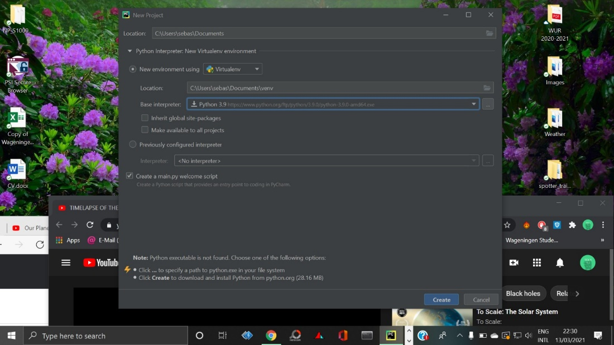
* On the top, you can create a new folder in which the files will be saved. Make sure to remember where the folder is located, as some other documents (from *GitHub*) have to be placed here.
* Make sure the “Base Interpreter” is one of the latest versions of *Python* (usually 3.8 or 3.9).
* If you unclick the *“create a main.py welcome script”* checkbox, you can add a file manually. However, it is a lot easier to use that file – which is automatically created when checked – for further purposes.

# Retrieve data from GitHub

In order to get the Web Application running, data and code is needed. Both are available for free on the *GitHub-page* for this project.

* Go to the *GitHub-page* of the *ChronosZoi 2021 Web Application*: <https://github.com/nadinefreistetter/hack_the_arctic_hackathon_2021>
* Click on the file called “app.py”. This file contains the source code for the Web Application.
* Copy the code shown into the *PyCharm-file*. Make sure the *PyCharm-file* is empty before copying the lines of code.
* Go back to the *GitHub-page* and click on the file called “hta.csv”. This file contains the data based on the trends observed during the research and data analysis.
* On the right side, click on “Raw”. A blank webpage with just characters will show up. Click right on the blank space and click on “Save as”. The file has to be saved in the same directory as the *PyCharm*­*-file* in order to work properly. Once the correct file is selected, save the data-file.

# Getting a link to (and opening) the Web Application

Once both the code- and data files have been retrieved from *GitHub*, the final step is to create a local server by running the code.

* First, *Python* needs to be selected as an Interpreter. In order to do this, click on “Add Configuration” (top-right), click on the “+” sign and then select “Python”.
* Once “Python” is selected, there will appear multiple things on the right hand side of the screen. On the top, the “Script Path” needs to be filled in. This is just the path to the *PyCharm-file*. By clicking on the ‘folder’ the file can be selected and the path will be automatically determined.
* Make sure that the “Python Interpreter” is set to one of the most recent versions of *Python* (often version 3.8 or 3.9). Then click “OK”.
* The last step is to check if all the packages needed are installed. To check whether this is the case and/or to install additional packages, go to “File” 🡪 “Settings” 🡪 “Project ([name you gave])” 🡪 “Python Interpreter”.

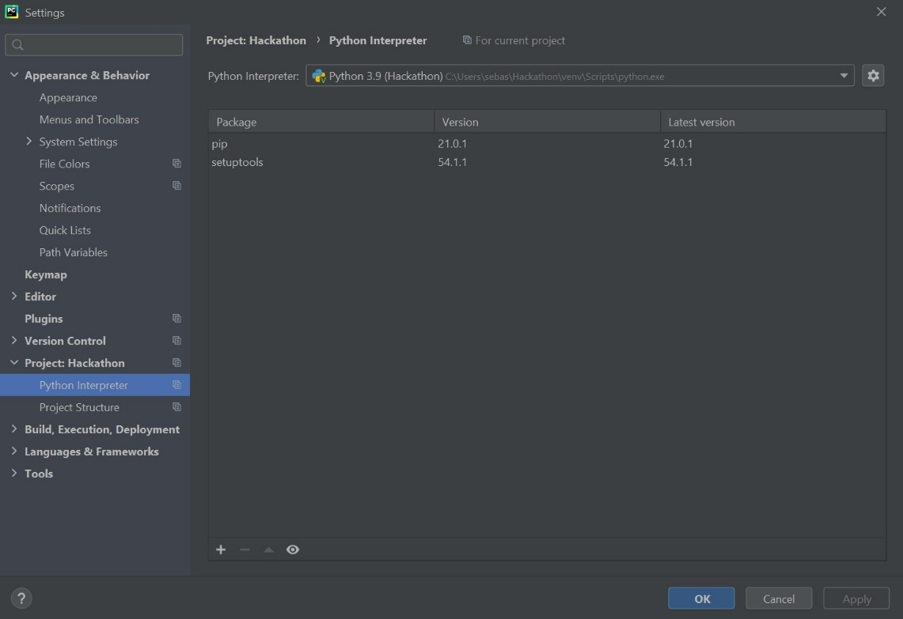

* On the right hand side, all installed packages will appear. The packages needed for this are: *dash, dash-daq, dash-core-components, dash-html-components, pandas and plotly-express*.
* If one or more of the packages are not installed, you can install them by clicking on the “+” sign. Just type in the name of the package and click on “Install”. A (green) message will pop up when the package is installed.
* When all the packages are installed, click “OK”.
* Go back to the code/script and *run the file* by clicking on the green ‘Play-button’. In the lower screen (under the actual code) a link will appear, with a *http://* note and a few numbers. If you paste this link in a browser, you will be able to view the interactive *ChronosZoi* *2021 Web Application*. 